**Assignment - 2**

|  |  |
| --- | --- |
| **Student Name/ID Number:** | W.A. Chathushi Dilhari Jayarathna |
| **Unit Number and Title:** | Uni 01 / Front End Web Development |
| **Academic Year:** | 2022/23 |
| **Unit Assessor:** |  |
| **Project Title:** | Website using HTML,CSS & Javascript (ABC Learning Center) |
| **Issue Date:** | 31/03/2022 |
| **Submission Date:** | 04/05/2022 |
| **Internal Verifier Name:** |  |
| **Date:** | 15/04/2022 |

|  |
| --- |
| **Learner declaration** |
| I certify that the work submitted for this assignment is my own and research sources are fully acknowledged.  Student signature: Chathushi Date: 04/05/2022 |

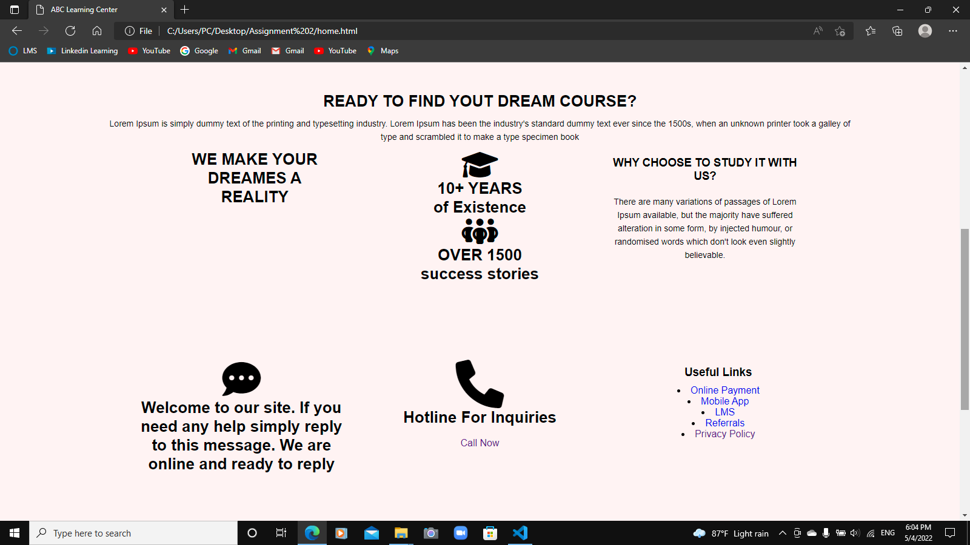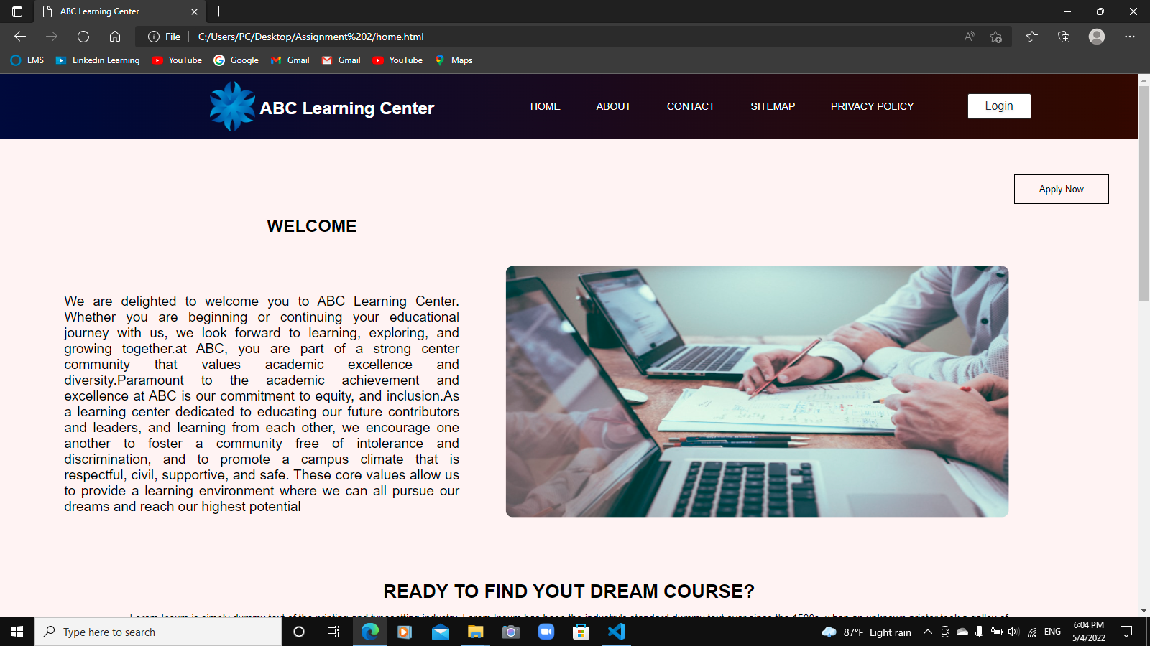**HOME PAGE**

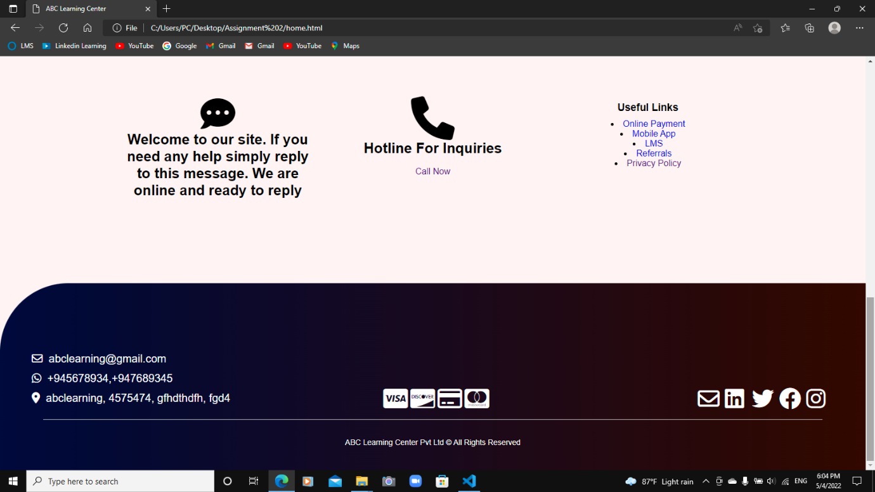

**ABOUT US PAGE**

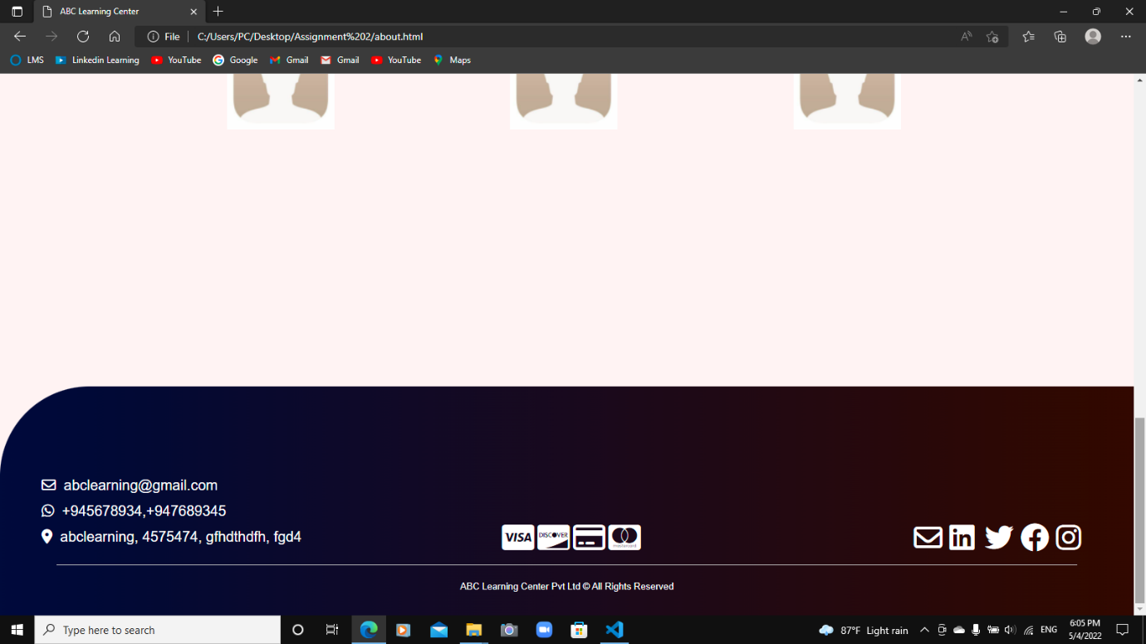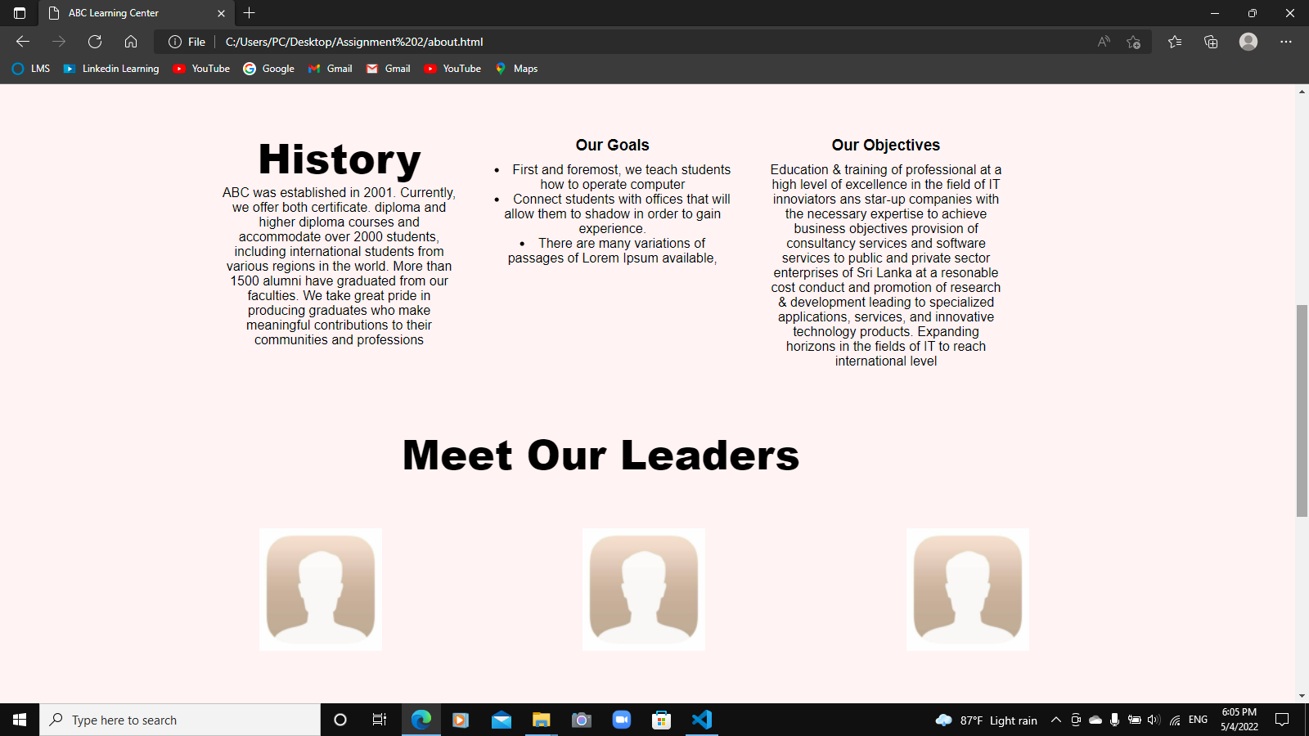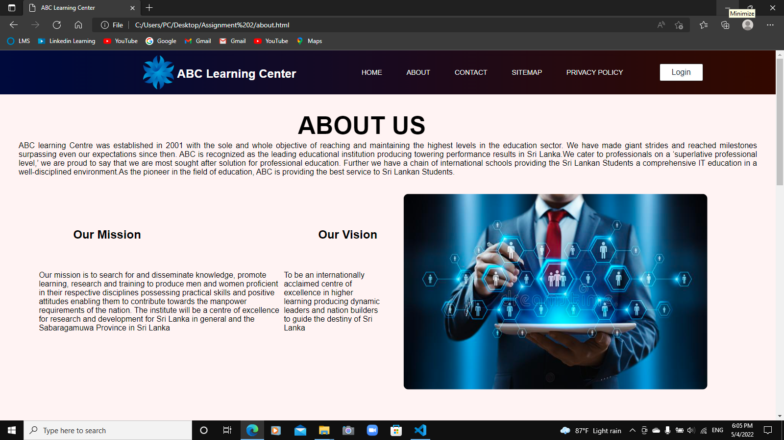

**CONTACT US PAGE**

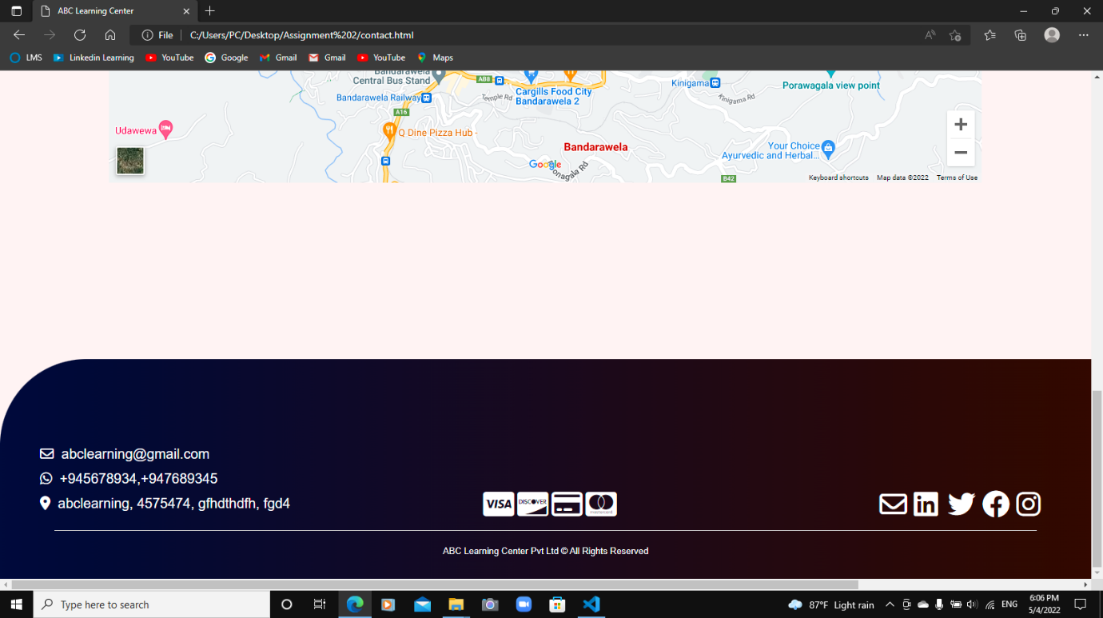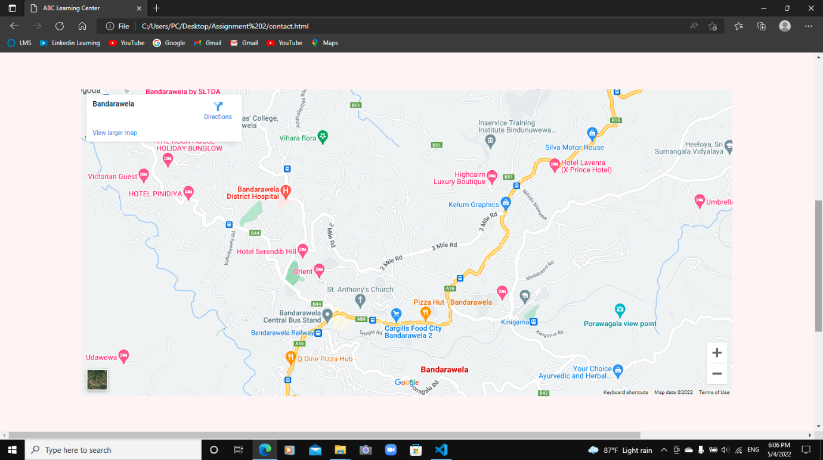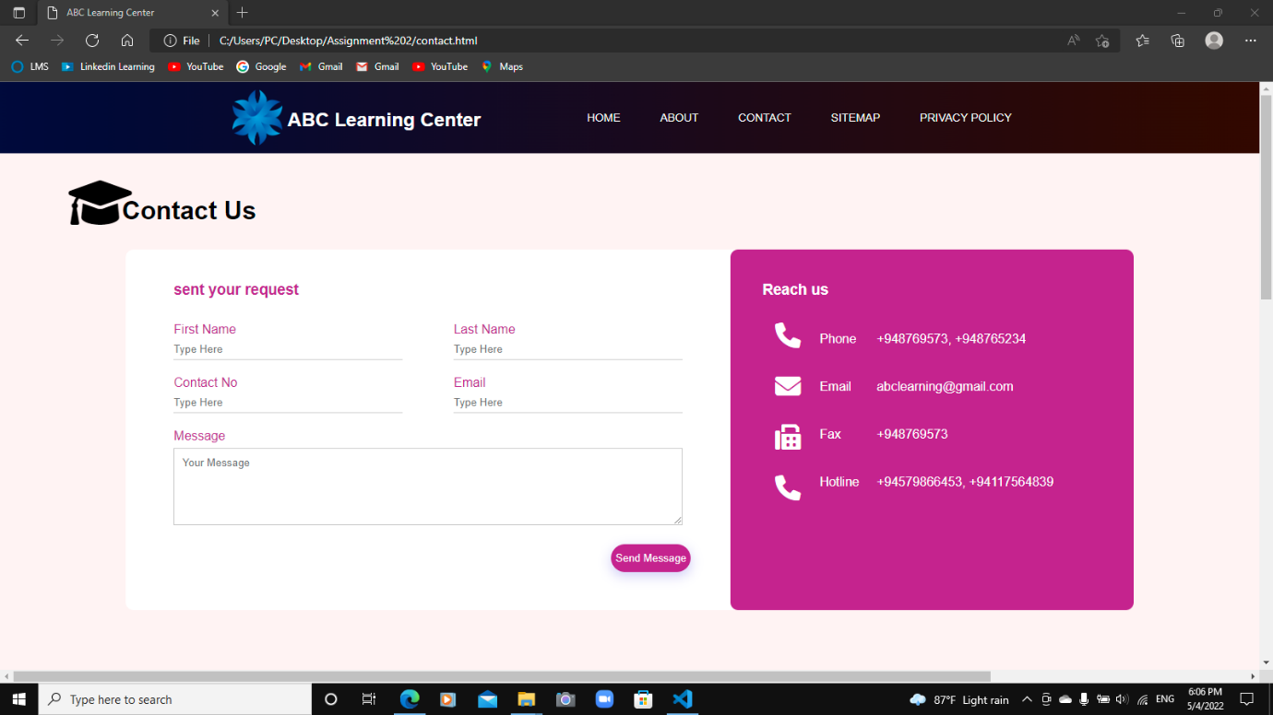

**SITEMAP PAGE**

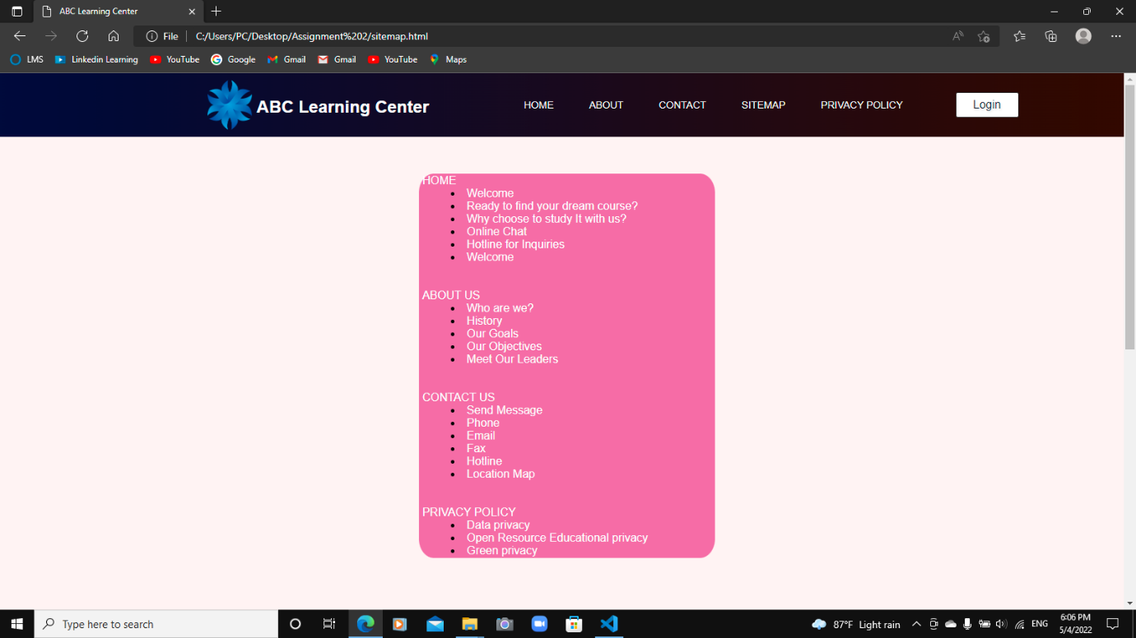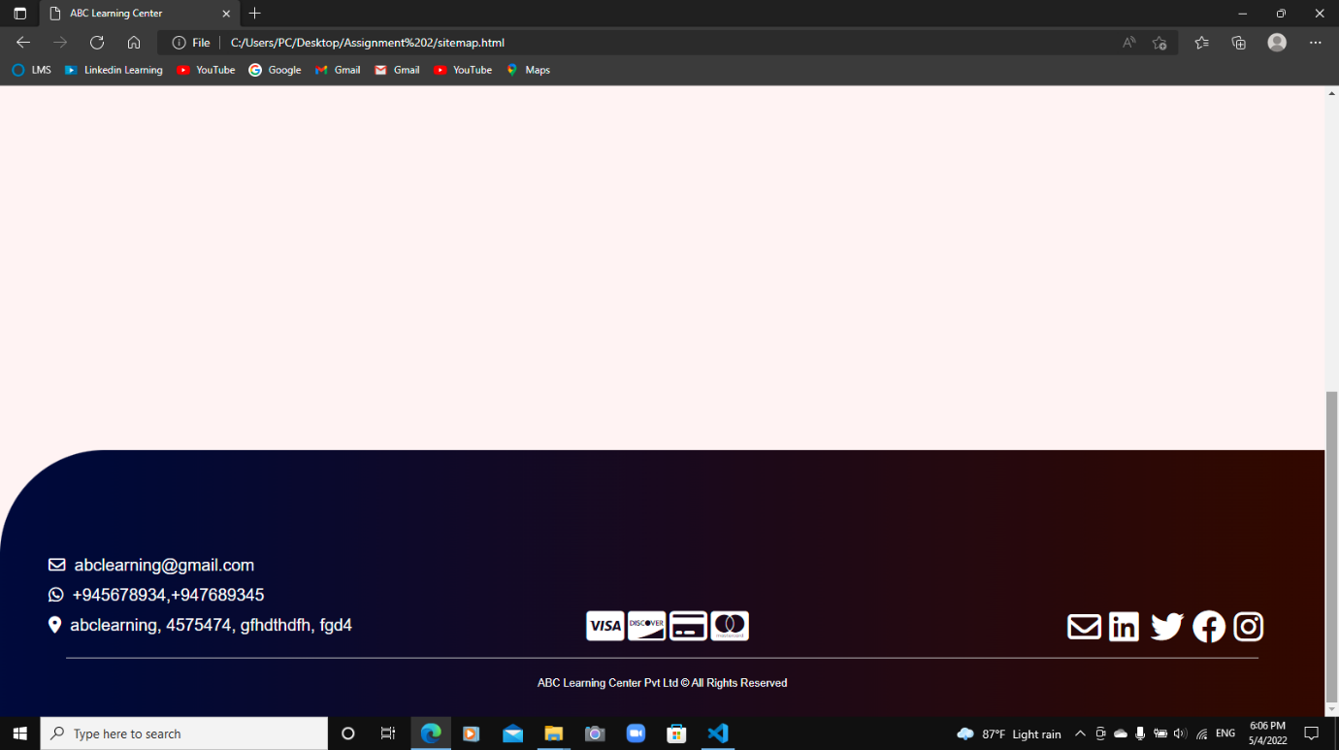

**PRIVACY POLICY PAGE**

